SenseView D600
User Manual



HIMS Co., Ltd.
TEL: +82 42 864 4460
FAX: +82 42 864 4462
E-mail: hims@himsintl.com
http://www.himsintl.com



CONTENTS

1. WHAT ARE IN THE PACKAGE 1

2. OVERVIEW 3

3. HOW TO INSTALL(Connecting to the Monitor) 4

4. HOW TO USE 10
4.1 Power On/Off 10
4.2 Line Marker/Window Marker 11
4.3 Zoom In/Zoom Out 12
4.4 Selection of Color Modes 14
4.5 Brightness Control of Screen(Monitor) 17
4.6 Focus Lock 17
4.7 The SenseView D600 and PC Switching 18
4.8 Picture Ratio Set 19
4.9 Light On/Off 19

5. SPECIFICATION 20

1. WHAT ARE IN THE PACKAGE

You can find the below items in the package of the SenseView D600.

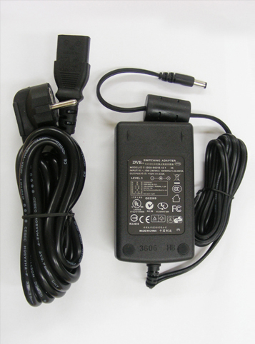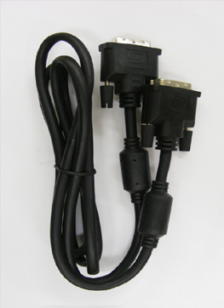
AC adapter Cable for DVI connection-2EA

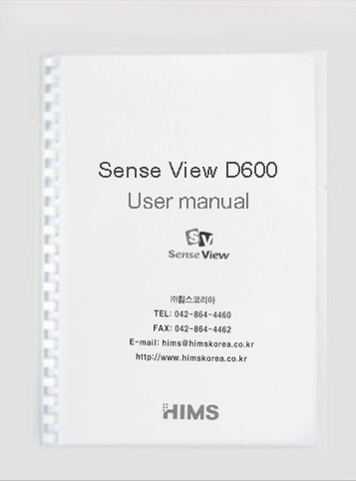
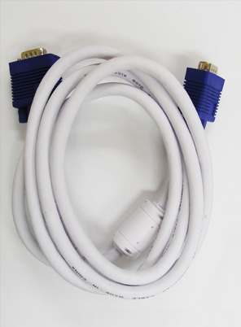
Cable for PC connection(VGA)-2EA User manual
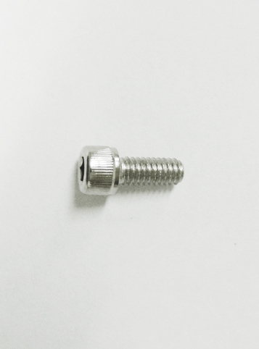
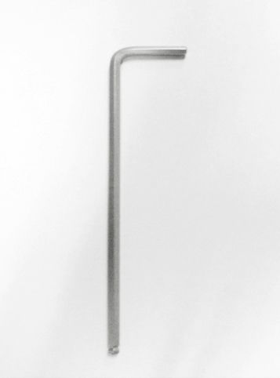

Allen Screw Allen Key

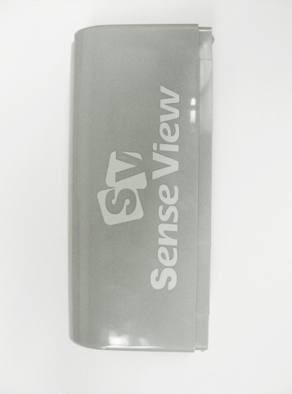

Cable Cover

If your package does not include all the listed items above, please contact your retailer or HIMS Co., Ltd.

2. OVERVIEW
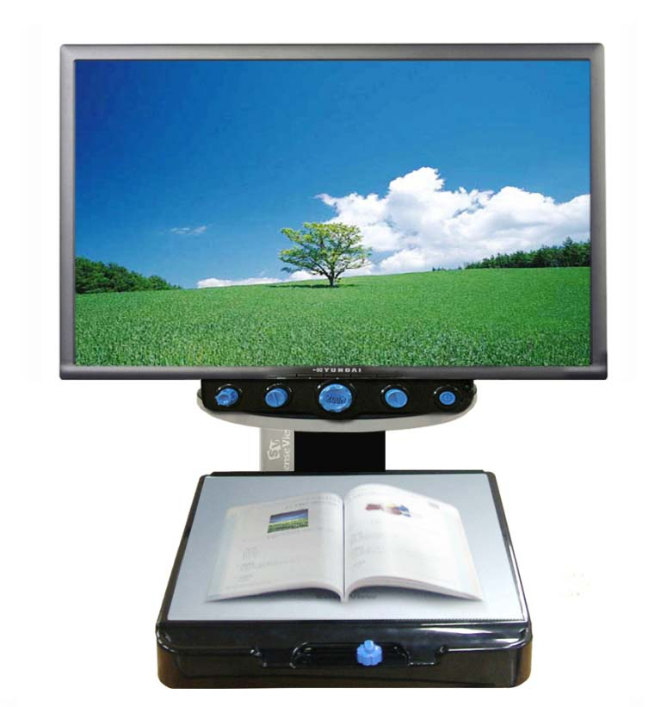
LCD Monitor
Power On/Off
Marker
Zoom In/Out
Table Lock
Color Mode
Brightness
Reading Table
Front Controller
Cable Cover

<Front Side>
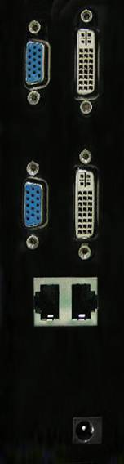
Video Output port(VGA/DVI-D)
Video Input port(VGA/DVI-D)
Front Panel Connection
DC-IN

<Left Side>

3. HOW TO INSTALL(Connecting to the Monitor)

- In case of the SenseView D600 with the monitor;

- The SenseView D600 is composed of the Magnification Module(left picture) and the Display Module(right picture).
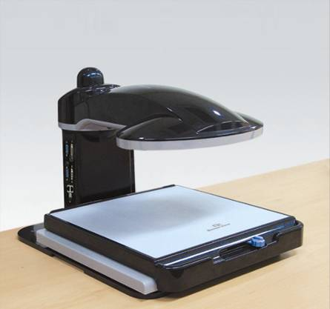
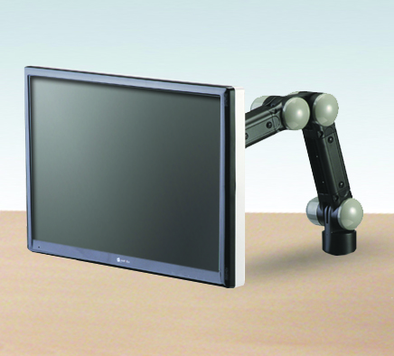

- Place the SenseView D600 on the table and remove the cab placed on the top of the Magnification’s pillar.
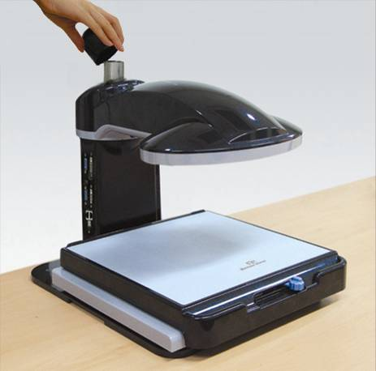

- Connect the Display Module to the Magnification Module’s pillar where you removed the cap, as show below.

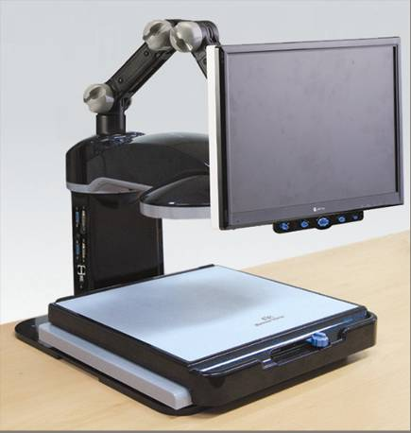

- After connection, screw up joined parts between the Magnification Module and the Display Module using the Allen key.
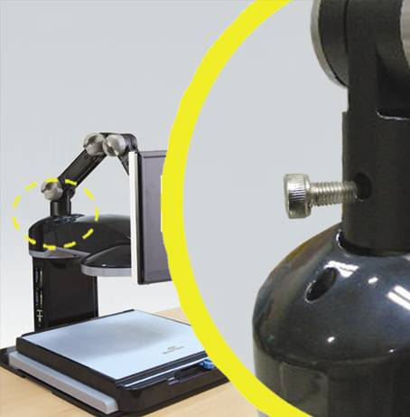

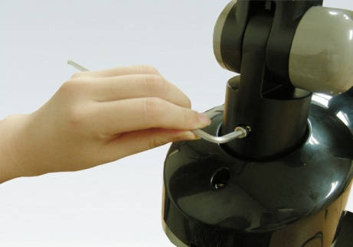

- Connect VGA(or DVI-D) cable to the Display Module. And connect the Power cable of the monitor to the Display Module.
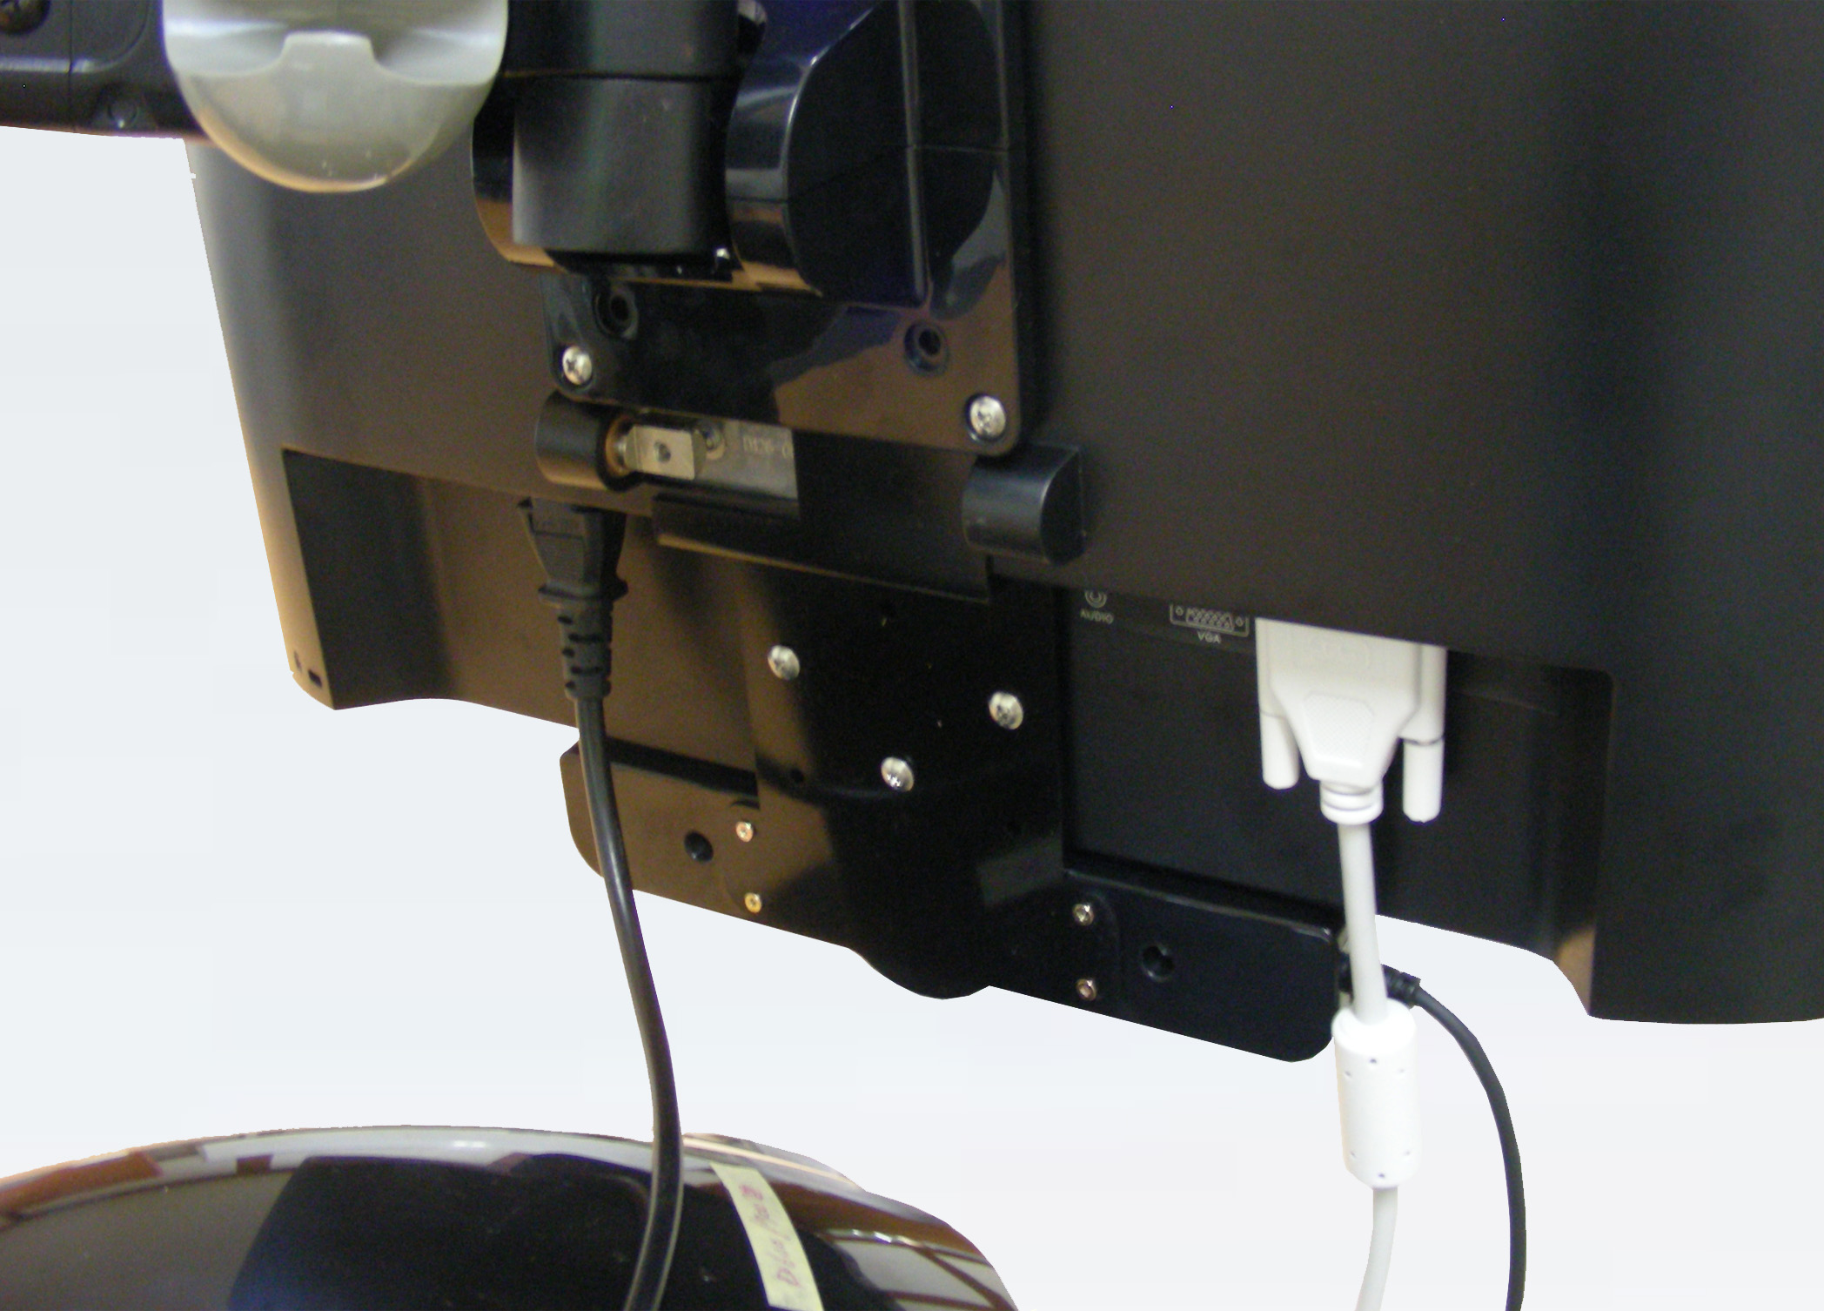
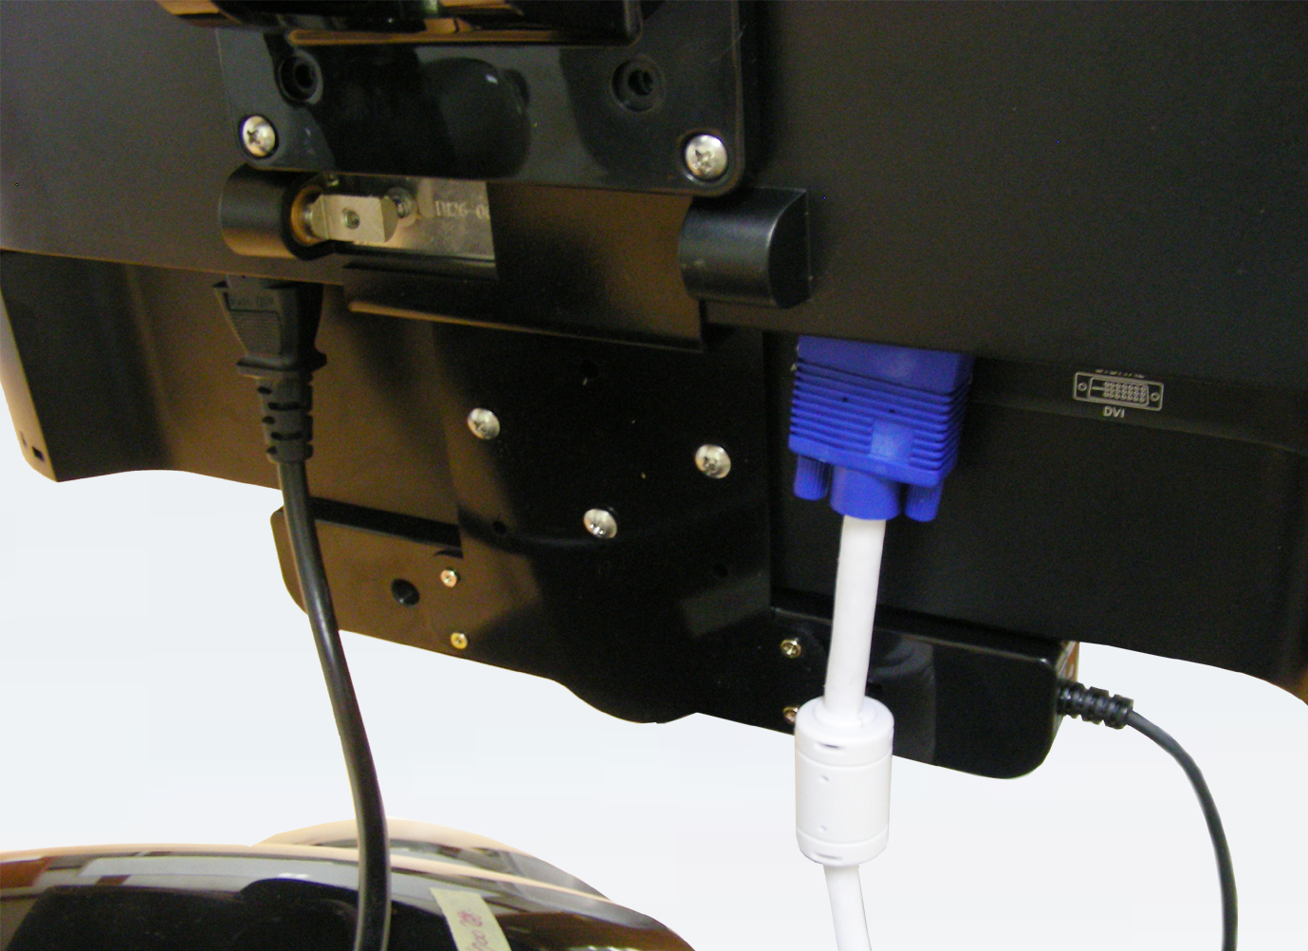

<VGA> <DVI-D>

- Insert the VGA(or DVI-D) cable, the Front Controller cable and the Power cable of the Display Module in the parts of the arm as show below.
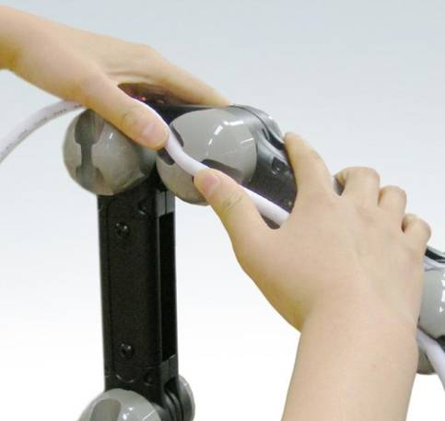

- Connect the other end of VGA cable(or DVI-D cable), the Front Controller cable and the Power cable of AC adapter to the port of the Magnification Module through hole of cable cover as show below. Please use adequate port for each cable.

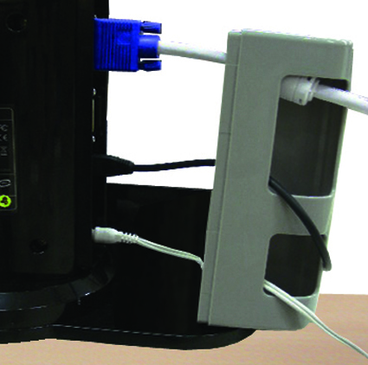

- Close cable cover after connection of cable.

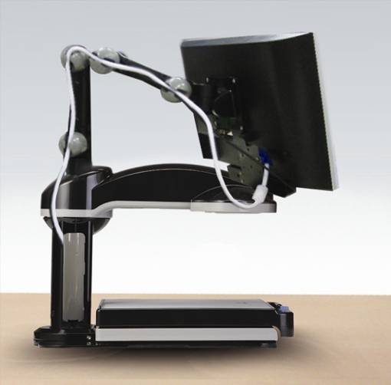

- Connect the other ends of the Power cable from the Magnification Module and the Display Module to the wall socket.

- In case of the SenseView D600 only;

- The SenseView D600 is composed of the Magnification Module only.
- Connect VGA(or DVI-D) cable and the Power cable to the monitor.
- Connect the other end of VGA cable(or DVI-D cable), the Front Controller cable and the Power cable of AC adapter to the port of the Magnification Module through hole of cable cover. Please use adequate port for each cable.
- Close cable cover after connection of cable.
- Connect the other ends of the Power Cable from the Magnification Moduel and the monitor to the wall socket.

- Do not connect or disconnect the Front Controller cable to or from the Magnification Module when the SenseView D600 is tunred on, it will cause operation error of the SenseView D600.
- Do not connect LAN cable to the port of Front Controller connection, it will cause faulty of the SenseView D600.

If you want to use one monitor for the SenseView D600 and the PC by switching, the monitor should be connected the video output of the SenseView D600 and the video output of the PC should be connected to the video input of the SenseView D600.

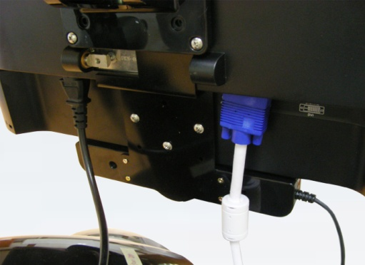
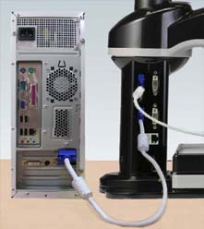

<VGA>
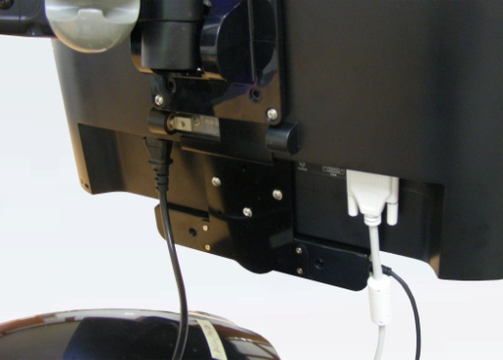
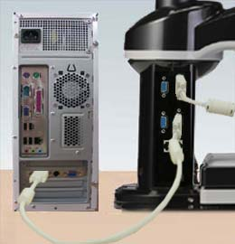

<DVI-D>

If you use VGA cable for connection of the monitor with the SenseView D600, please use VGA cable for connetion to the PC. Also, if you use DVI-D cable for the monitor, please use same cable for the PC. If you use different cable for the monitor and the PC, display on the screen is not working properly.

Please refer to the following method for connection of the PC;
- Check connecting status of the monitor with output port of VGA/DIV-D on the body using VGA cable or DVI-D cable.
- After checking, connect the input port of the body to the port of VGA or DVI-D on the PC using VGA cable or DVI-D cable. (You have to use same port with monitor.)
- The monitor and the PC should be powered by their own adapters for power cable.
- Please do not use VGA cable and DVI-D cable simultaneously. It may cause the operation error.

4. HOW TO USE

4.1 Power On/Off
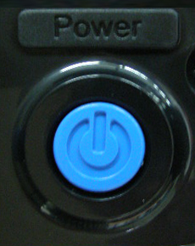
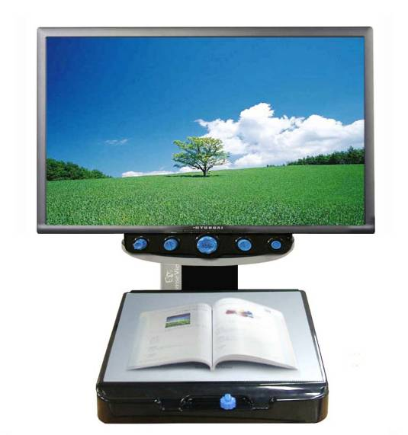

Press the ‘Power’ button placed on right of the front side on the SenseView D600 and then your SenseView D600 starts working and light on. And also turn on the power of the monitor.
Press the ‘Power’ button again to turn off the power.

4.2 Line Marker/Window Marker

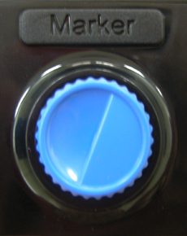

When you want to read a book or material with unit of line or divide the table into line and row, Line/Window maker will guide you in reading a book or material and table.
There are 4 kinds of Makers.

- Horizontal Line Marker: Press the ‘Marker’ dial button, the Horizontal Line will show up. And then turn the ‘Marker’ dial button to the left side, the line will go up and turn to the right side, the line will go down.
- Vertical Line Marker: When the ‘Horizontal Line Marker’ is on the screen, press the ‘Marker’ dial button again, the Vertical Line will show up. And then turn the ‘Marker’ dial button to the right side, the line will go to the right and turn to the left side, the line will go to the left.
- Horizontal Window Marker: When the ‘Vertical Line Marker’ is on the screen, press the ‘Marker’ dial button again, the ‘Horizontal Window Marker’ will show up. And then turn the ‘Marker’ button to the right and left side, the Horizontal Window Maker size will change(getting bigger and smaller).
- Vertical Window Marker: When the ‘Horizontal Window Marker’ is on the screen, press the ‘Marker’ dial button again, the ‘Vertical Window Marker’ will show up. And then turn the ‘Marker’ dial button to the right and left side, the Vertical Window Marker size will change(getting bigger and smaller).

When you press the ‘Marker’ dial button each time, the Marker function will circulate. And if you press the ‘Marker’ dial button one more time when the ‘Vertical Window Marker’ is on the screen, the maker function will disappear.
Even the SenseView D600 is turned off, the marker settings will be saved. In other words, the SenseView D600 is turned on again, the last function will show up.

- The SenseView D600 does not show the user message on the screen when using Line/Window Marker function.

4.3 Zoom In/Zoom Out

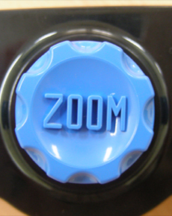

The Zoom level of the SenseView D600 can be adjusted between level 1 to level 16 using the ‘Zoom’ dial button placed at the center of the Front Controller.

Please refer to the following method for Zoom In/Zoon Out;

- Zoom In: Turn the ‘Zoom’ dial button to the right side.
- Zoom Out: Turn the ‘Zoom’ dial button to the left side.
- If you press the ‘Marker’ dial button more than 5 seconds and release it, “ZOOM/D” message show up and Zoom Mode will be changed to Digital Zoom Mode and Zoom Level will increase up to level 19 and you can magnify images until 73 times.
- Press the ‘Marker’ dial button more than 5 seconds again and release it, “ZOOM/O” message show up and the Zoom Mode will go back to the Optical Zoom Mode and Zoom Level will decrease to level 16.

When the power is off, the SenseView D600 will save the last Zoom Level and Zoom Mode and if you turn the SenseView D600 on again, it shows last Zoom Level and Zoom Mode again.

4.4 Selection of Color Modes

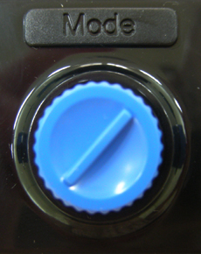

Color modes can be adjusted using ‘Mode’ dial button placed on the left side of the ‘Zoom’ dial button. The SenseView D600 has 35 color modes and it memorizes 8 modes basically. If you turn the ‘Mode’ dial button to the right side, circulating Mode 1 to Mode 8 and turn to the left side, re-circulating Mode 8 to Mode 1.

You can select the colors of color mode 5 to color mode 8 from 35 colors that are listed on the color table shown on the next page.
You CANNOT change colors of mode 1 to mode 4.

No. | Text Color | Background Color
1 | Full Color
2 | Monochrome
3 | Black | White
4 | White | Black
5 | Negative Color
6 | Blue | White
7 | White | Blue
8 | Green | White
9 | White | Green
10 | Red | White
11 | White | Red
12 | Pink | White
13 | White | Pink
14 | Bluish Green | White
15 | White | Bluish Green
16 | Yellow | White
17 | White | Yellow
18 | Black | Red
19 | Red | Black
20 | Black | Green
21 | Green | Black
22 | Black | Blue
23 | Blue | Black
24 | Black | Pink
25 | Pink | Black
26 | Black | Bluish Green
27 | Bluish Green | Black
28 | Black | Yellow
29 | Yellow | Black
30 | Red | Bluish Green
31 | Bluish Green | Red
32 | Green | Pink
33 | Pink | Green
34 | Blue | Yellow
35 | Yellow | Blue

How to select the colors is explained as follows;

- Turn the ‘Mode’ dial button in order to move to one mode among mode 5 to mode 8 and stop at the color mode number and then press the ‘Mode’ dial button more than 3 seconds.
- The message of “MODE SETUP” will be displayed on the screen for a while and then “GENERAL MODE” will be displayed.
- When “GENERAL MODE” Message show up on the screen, turn the ‘Mode’ dial button and find your preference color.
- If you find your preference color, press the ‘Mode’ dial button. Then “SAVE? YES” message will be displayed.
- Press the ‘Mode’ dial button again and then “CONFIRM” will be displayed and the the SenseView D600 will save the selected color at the selected color mode number and show the selected color.
- If you do not want to save the changed color, turn the ‘Mode’ dial button and press it when “SAVE? No” will be displayed on the screen. And then the SenseView D600 will show “EXIT” and will cancel saving the color selection.

4.5 Brightness Control of Screen(Monitor)
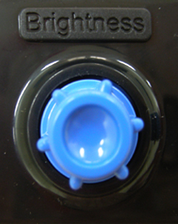

The Brightness on the screen of the SenseView D600 can be adjusted between level 1 to level 25 and the default level is 13 using the “Brightness” dial button placed on the left side of the Front Controller.

- Brightness Up: Turn the ‘Brightness’ dial button to the right side
- Brightness Down: Turn the ‘Brightness’ dial button to the left side.

You can settle specified Brightness according to each Color Mode. In other words, you can settle level 10 of Brightness for Color Mode 1 and also can settle level 20 of Brightness for Color Mode 2. Adjust the Brightness along with your preference.

4.6 Focus Lock
The SenseView D600 has the function of automatic focus and it will make user easy to read a book or material since it catch a focus automatically for moving objects or changing objects to the high and row. But you
have to use the ‘Focus Lock’ and focus of note or book when you write something. Since the SenseView D600 will focus on your hand or pen automatically as writing.
Please refer to the following method for the ‘Focus Lock’;
.
- Focus Lock: Press the ‘Brightness’ dial button more than 3 seconds and release it then the message of “F/LOCK” will show up on the screen and the ‘Focus Lock’ begin to work.
- Release Focus Lock(Auto Focus): Press the ‘Brightness’ dial button again more than 3 seconds and release it on the status of ‘F/LOCK’ and then the message of “F/AUTO” will show up on the screen and will go back to Auto Focus.

4.7 The SenseView D600 and PC Switching

You can use one monitor for displaying PC and the SenseView D600. Please refer to the following method;

- Turn off the power of the SenseView D600
- Please make sure the connection between the SenseView and monitor.
- If the SenseView is connected to the monitor using VGA cable, connect the VGA output of the PC to the input of the Sense View using VGA cable.
If the SenseView is connected to the monitor using DVI-D cable, connect the DVI-D output of the PC to the DVI-D input of the Sense View
- Turn on the power of PC and monitor, then PC screen will be displayed on the monitor. This is called “PC Mode.”
- At the ‘PC Mode’, if you turn on the power of SenseView, the magnifier image will be displayed on the monitor. This is called “SenseView Mode” and is a default mode of the SenseView.
- While the ‘SenseView Mode’, press the ‘Brightness’ dial button again and then change to the ‘PC Mode’.
- Press the ‘Brightness’ dial button again to switch to the ‘SenseView Mode’.

- If you connect the monitor and the PC to the SenseView D600 using DVI-D cable, you have to turn the SenseView D600 on in advance and then turn on the PC. It starts working with ‘SenseView Mode’.

4.8 Picture Ratio Set

You can set picture ratio on the monitor between 4x3 and 16x9.
To change the picture ratio, turn off the power, press and hold “Marker” dial button and turn the SenseView D600 on. Then 4x3 or 16x9 will be displayed on the screen. The 16x9 ratio is default.

4.9 Light On/Off
If you install the SenseView D600 for the first time, the lighting is on. If you want to turn it off, move your hand from camera of the SenseView D600 to the pillar and then you can find lighting switch.

5. SPECIFICATION
Magnification |  | 4x~73x(19" monitor)
Power |  | 12V/3A
Size |  | 340mm(w) x 467mm(d) x 361mm(h)  (except the Hinge)
Basic Mode |  | 1. Full Color  2. Monochrome  3. Black / White  4. White / Black  5. Yellow / Black  6. Blue / Yellow  7. Blue / White  8. White / Blue
Selection of Color Mode |  | - Full Color, Monochrome, 16 kinds of high contrast color (Black/White, Blue/White, Green/White, Red/White, Pink/White, Bluish Green/White,  Yellow/White, Black/Blue, Black/Green,  Black/Red, Black/Pink, Black/Bluish  Green, Black/Yellow, Bluish/Red,  Pink/Green, Yellow/Blue)  - Support negative mode for each color mode except Monochrome mode)
Weight |  | 11 Kg(including Display Module: 18Kg)
Output Resolution |  | 1024 X 768
In/Output | Input | - Input port for connection of the PC(VGA)  - Support DVI-D
In/Output | Output | - Output port for connection of the monitor(VGA)  - Output port for connection of the monitor(DVI-D)

※ NOTE: This user guide will be differed from actual operation due to improved function of products and it is subject to change and modified without prior notice.


NOTE: This equipment has been tested and found to comply with the limits for a Class B digital device, pursuant to part 15 of the FCC Rules. These limits are designed to pro-vide reasonable protection against harmful interference in a residential installation.
This equipment generates, uses and can radiate radio frequency energy and, if not in-stalled and used in accordance with the instructions, may cause harmful interference to radio communications. However, there is no guarantee that interference will not occur in a particular installation. If this equipment does cause harmful interference to radio or television reception, which can be determined by turning the equipment off and on, the user is encouraged to try to correct the interference by one or more of the following measures:
-Reorient or relocate the receiving antenna.
-Increase the separation between the equipment and receiver.
-Connect the equipment into an outlet on a circuit different from that to which the receiver is connected.
-Consult the dealer or an experienced radio/TV technician for help.

CAUTION: Changes or modifications not expressly approved by the manufacturer responsible for compliance could void the user’s authority to operate the equipment.

