SenseView D700
User Manual



HIMS Co., Ltd.
TEL: +82 42 864 4460
FAX: +82 42 864 4462
E-mail: hims@himsintl.com
http://www.himsintl.com



CONTENTS

1. WHAT ARE IN THE PACKAGE 1
2. OVERVIEW 3
4. HOW TO USE 11
4.1 Power On/Off 11
4.2 Line Marker/Window Marker 13
4.3 Zoom In/Zoom Out 15
4.4 Selection of Color Modes 17
4.5 Brightness Control of the Screen(Monitor) 21
4.6 Focus Lock 22
4.7 Split Screen 24
4.8 Picture Ratio Set 28
4.9 Light On/Off 30
4.10 Setting Beep Sound and Voice 30
4.11 Setting Date and Times 31
5. SPECIFICATION 34

1. WHAT ARE IN THE PACKAGE

You can find the below items in the package of the SenseView D700.

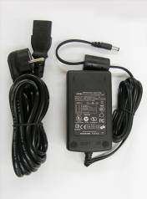
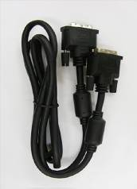

AC adapter Cable for DVI connection-2EA

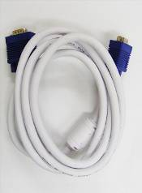
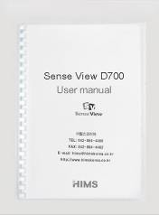

Cable for PC connection(VGA)-2EA User manual

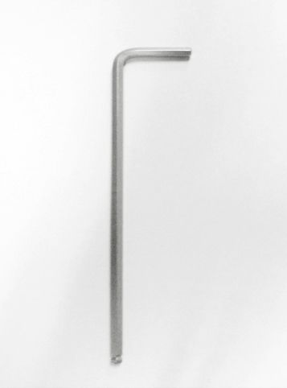
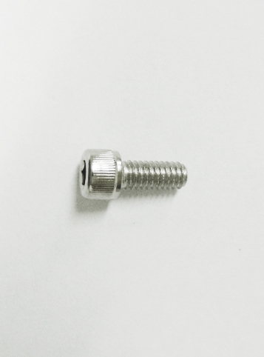

Allen Screw Allen Key

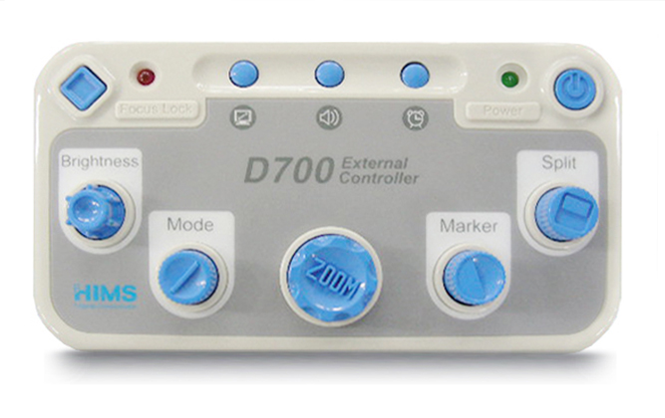
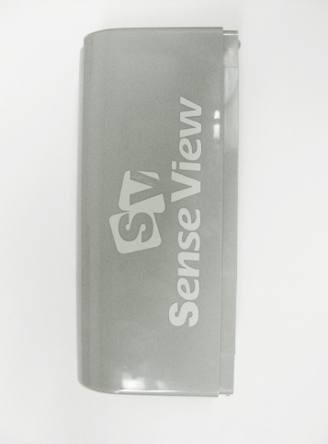

External Controller

Cable Cover

If your package does not include all the listed items above, please contact your retailer or HIMS Co., Ltd.

2. OVERVIEW

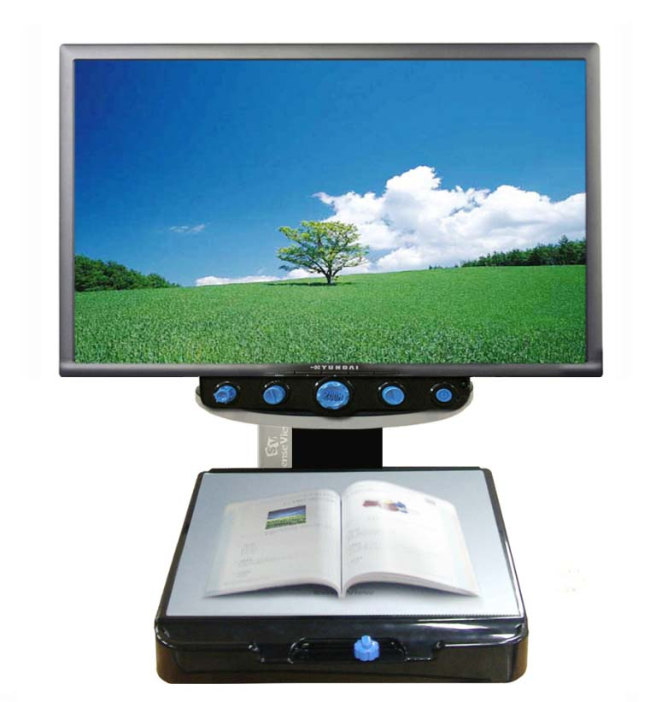
LCD Monitor
Power On/Off
Marker
Zoom In/Out
Table Lock
Color Mode
Brightness
Reading Table
Front Controller
Cable Cover

<Front Side>

Picture Ratio Set
Beep Sound and Voice

Date and Time

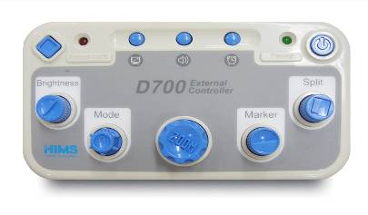
Focus Lock
On/Off indicator

Power On/Off indicator

Focus Lock

Power

Brightness

Mode
키

Split Screen

Marker

Zoom In/Out

<External Controller>

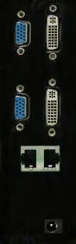
Video Output port(VGA/DVI-D)
Video Input port(VGA/DVI-D)
Front Panel /External Panel Connection
DC-IN
<Left Side View>

3. HOW TO INSTALL(Connecting to the Monitor)

- In case of the SenseView D700 with the monitor;

- The SenseView D700 is composed of the Magnification Module(left picture) and the Display Module(right picture)
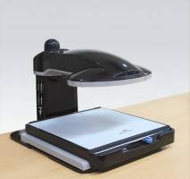
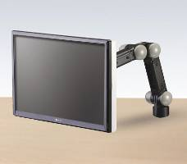

- Place the SenseView D700 on the table and remove the cab placed on the top of the Magnification’s pillar.
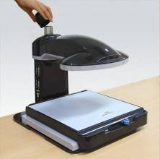

- Connect the Display Module to the Magnification Module’s pillar where you removed the cap, as show below.
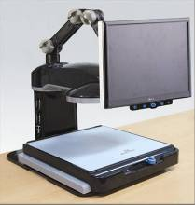

- After connection, screw up joined parts between the Magnification Module and the Display Module using the Allen Key.
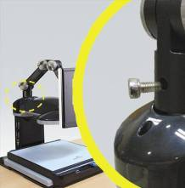

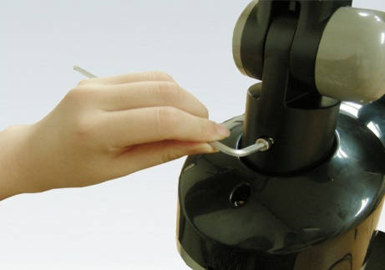

- Connect VGA(or DVI-D) cable to the Display Module. And connect the Power cable of the monitor to the Display Module.
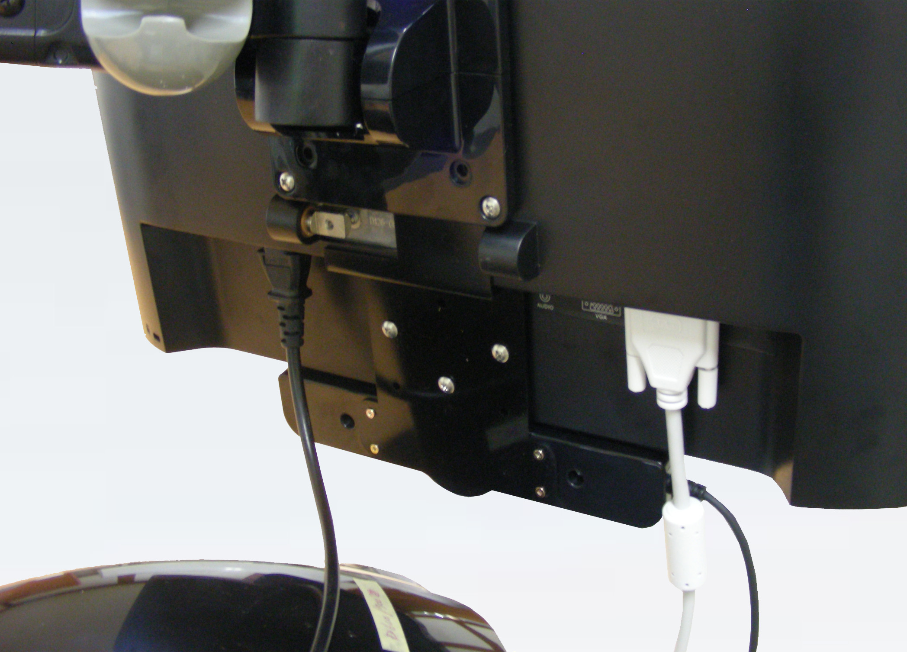
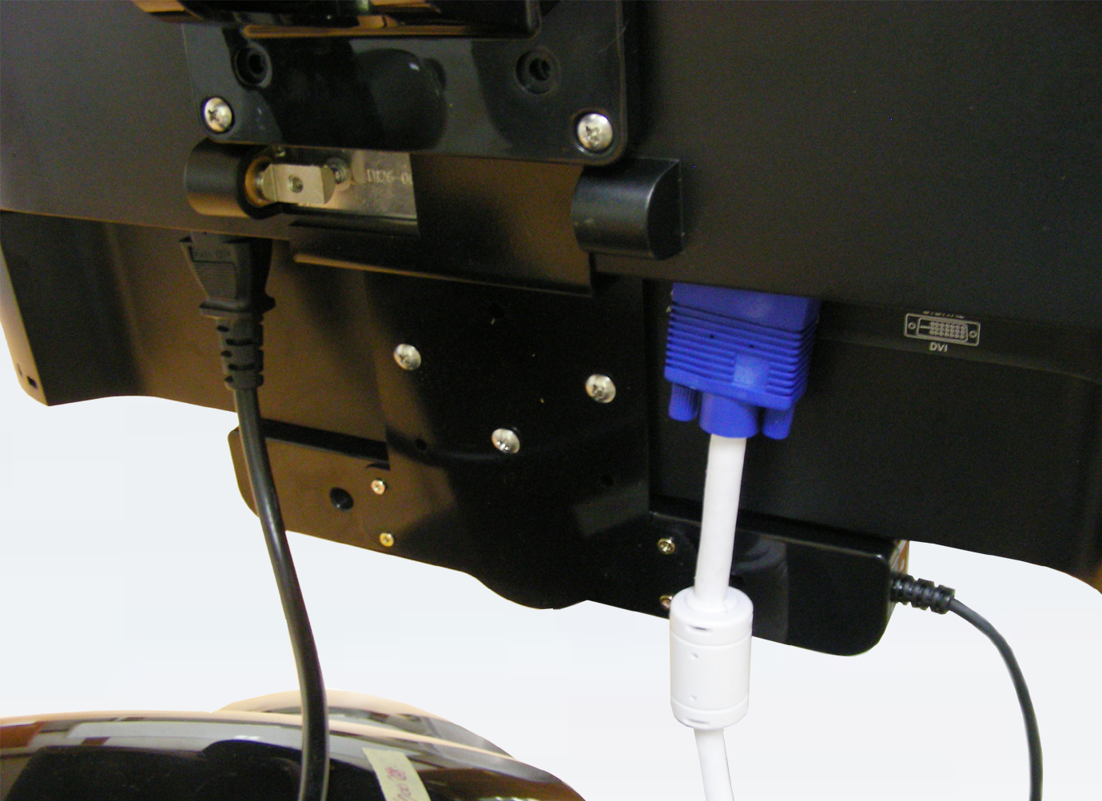

<DVI-D>

<VGA>

- Insert the VGA(or DVI-D) cable, the Front Controller cable and the Power cable of the Display Module in the parts of the arm as show below.

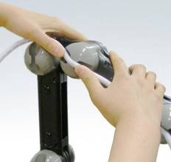

- Connect the other end of VGA cable(or DVI-D cable), the Front Controller cable, the External Controller cable and the Power cable of AC adapter to the port of the Magnification Module through hole of cable cover as below. Please use adequate port for each cable.

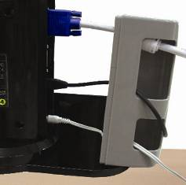

- Close cable cover after connection of cable.
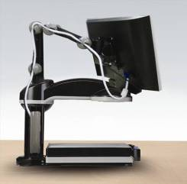

- Connect the other ends of the Power cable from the Magnification Module and the Display Module to the wall socket.
- In case of the SenseView D700 only;

- The SenseView D700 is composed of the Magnification Module only.
- Connect VGA(or DVI-D) cable and the Power cable to the monitor.
- Connect the other end of VGA cable(or DVI-D cable), the External Controller cable and the Power cable of AC adapter to the port of the Magnification Module through hole of cable cover. Please use adequate port for each cable.
- Close cable cover after connection of cable.
- Connect the other ends of the Power cable from the Magnificatio Module and the monitor to the wall socket.

- The Front Controller is not supplied if you purchase the SenseView without the Display Module.
- Do not connect or disconect the Front Controller cable and the External Controller cable to or from the Magnification Module when the SenseView D700 is turned on, it will cause operation error of the SenseView D700.
- Do not connect LAN cable to the port of Front Controller and External Controller connection, it will cause faulty of the SenseView D700.

If you want to use one monitor for the SenseView D700 and the PC by switching, the monitor should be connected the video output of the SenseView D700 and the video output of the PC should be connected to the video input of the SenseView D700.
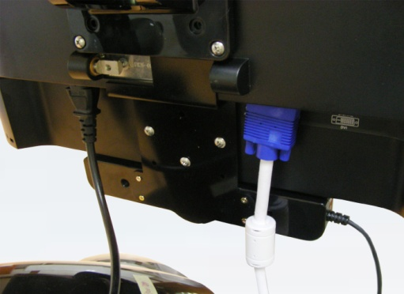
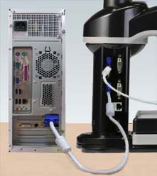

<VGA>

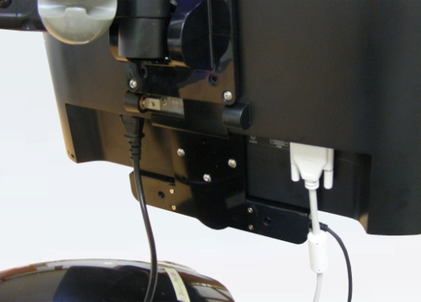
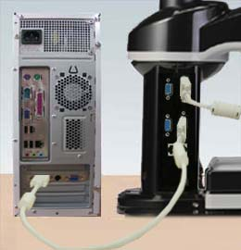

<DVI-D>

If you use VGA cable for connection of the monitor with the SenseView D700, please use VGA cable for connetion to the PC. Also, if you use DVI-D cable for the monitor, please use same cable for the PC. If you use different cable for the monitor and the PC, display on the screen is not working properly.

Please refer to the following method for connection between PC and Sense View D700;

- Check the connection between monitor and Magnification Module.

- If the monitor is connected to the Magnification Module using VGA cable, the connection between PC and the Magnification Module should be VGA, not DVI-D.
If connection between Magnification Module and monitor is DVI-D, the connection between Magnification Module and PC should be DVI-D, not VGA.
- The monitor and PC should be powered by their own adapters for power cable.
- Please do not use VGA cable and DVI-D cable
simultaneously. It may cause the operation error.

4. HOW TO USE

4.1 Power On/Off
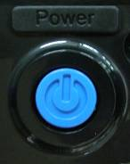
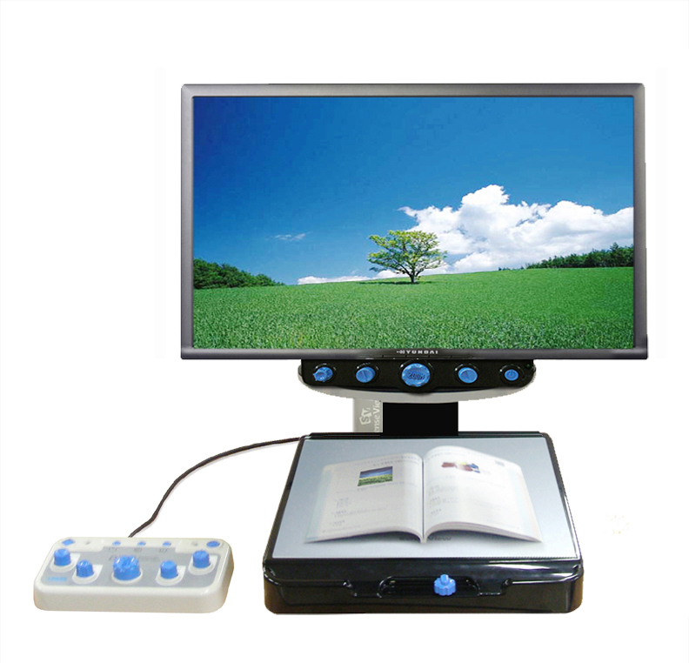

- In case of using the Front Controller
Press the ‘Power’ button placed on right of the Front Controller and then your SenseView D700 starts working and light on. And also turn on the power of the monitor.

- In case of using the External Controller

Press the ‘Power’ button on the External Controller and then Power On/Off LED indicator will be turned on and the SenseView D700 is turned on. And press the ‘Power’ button again, Power On/Off indicator light off and power of the SenseView D700 is off.

4.2 Line Marker/Window Marker
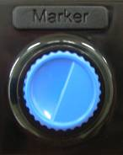

When you want to read a book or material with unit of line or divide the table into line and row, Line/Window maker will guide you in reading a book or material and table.
You can use Line Marker/Window Marker with same way at the Front Controller and the External Controller.
There are 4 kinds of Maker.

- Horizontal Line Marker: Press the ‘Marker’ dial button, the Horizontal Line will show up. And then turn the ‘Marker’ dial button to the left side, the line will go up and turn to the right side, the line will go down.
- Vertical Line Marker: When the ‘Horizontal Line Marker’ is on the screen, press the ‘Marker’ dial button again, the Vertical Line will show up. And then turn the ‘Marker’ dial button to the right side, the line will go to the right and turn to the left side, the line will go to the left.
- Horizontal Window Marker: When the ‘Vertical Line Marker’ is on the screen, press the ‘Marker’ dial button again, the ‘Horizontal Window Marker’ will show up. And then turn the ‘Marker’ button to the right and left side, the Horizontal Window Maker size will change(getting bigger and smaller).
- Vertical Window Marker: When the ‘Horizontal Window Marker’ is on the screen, press the ‘Marker’ dial button again, the ‘Vertical Window Marker’ will show up. And then turn the ‘Marker’ dial button to the right and left side, the Vertical Window Marker size will change(getting bigger and smaller).

When you press the ‘Marker’ dial button each time, the Marker function will circulate. And if you press the ‘Marker’ dial button one more time when the ‘Vertical Window Marker’ is on the screen, the maker function will
disappear.
Even the SenseView D700 is turned off, the marker settings will be saved. In other words, the SenseView D700 is turned on again, the last setting of this function will show up.

- The SenseView D700 does not show the user message on the screen when using Line/Window Marker function.

4.3 Zoom In/Zoom Out

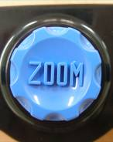

The Zoom level of the SenseView D700 can be adjusted from level 1 to level 16 using the ‘Zoom’ dial button.
You can use Zoom In/Out with same way on the Front Controller and the External Controller.
Please refer to the following method for Zoom In/Zoom Out;
- Zoom In: Turn the ‘Zoom’ dial button to the right side
- Zoom Out: Turn the ‘Zoom’ dial button to the left side.

There are two Zoom modes, one is Optical Zoom and the other one is Digital Zoom. Digital Zoom provides more bigger magnification rate.
But it is a different between the Front Controller and the External Controller for changing method of Digital Zoom to Optical Zoom.

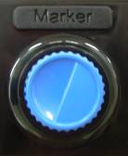

- In case of using the Front Controller
If you press the ‘Marker’ dial button more than 5 seconds and release it, “ZOOM/D” message show up and Zoom Mode will be changed to Digital Zoom Mode and Zoom Level will increase up to level 19 and you can magnify images until 73 times.
Press the ‘Marker’ dial button more than 5 seconds again and release it, “ZOOM/O” message show up and the Digital Zoom Mode will go back to the Optical Zoom Mode and Zoom Level will decrease to level 16.

- In case of using the External Controller
Press the ‘Focus Lock’ button and hold on, turn the ‘Zoom’ dial button to the right side. “ZOOM/D” message shows up and Zoom Mode will be changed to Digital Zoom Mode and Zoom Level will increase up to level 19 and you can magnify images until 73 times.
If you want to go back to Optical Zoom Mode, turn the ‘Zoom’ dial button to the left side while press the ‘Focus Lock’ button. Then “ZOOM/O” message shows up and it will be changed to Optical Zoom Mode and Zoom Level will decrease to level 16.

When the power is off, the SenseView D700 will save the last settings of Zoom Level and Zoom Mode and if you turn the SenseView D700 on again, it shows the same Zoom Level and Zoom Mode again.

4.4 Selection of Color Modes

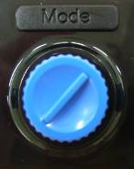

Color modes can be adjusted using ‘Mode’ dial button placed on the left side of the ‘Zoom’ dial button. The SenseView D700 has 35 color modes and it memorizes 8 modes basically.
You can use Selection of Color Modes with same way at the Front Controller and the External Controller.
If you turn the ‘Mode’ dial button to the right side, circulating Mode 1 to Mode 8 and turn to the left side, re-circulating Mode 8 to Mode 1.

You can select the colors of mode 5 to color mode 8 from 35 colors that are listed on the color table shown on the next page.
You CANNOT change colors of mode 1 to mode 4.

No. | Text Color | Background Color
1 | Full Color
2 | Monochrome
3 | Black | White
4 | White | Black
5 | Negative Color
6 | Blue | White
7 | White | Blue
8 | Green | White
9 | White | Green
10 | Red | White
11 | White | Red
12 | Pink | White
13 | White | Pink
14 | Bluish Green | White
15 | White | Bluish Green
16 | Yellow | White
17 | White | Yellow
18 | Black | Red
19 | Red | Black
20 | Black | Green
21 | Green | Black
22 | Black | Blue
23 | Blue | Black
24 | Black | Pink
25 | Pink | Black
26 | Black | Bluish Green
27 | Bluish Green | Black
28 | Black | Yellow
29 | Yellow | Black
30 | Red | Bluish Green
31 | Bluish Green | Red
32 | Green | Pink
33 | Pink | Green
34 | Blue | Yellow
35 | Yellow | Blue
How to select the colors is explained as follows;

- Turn the ‘Mode’ dial button in order to move to one mode among mode 5 to mode 8 and stop at the color mode number and then press the ‘Mode’ dial button more than 3 seconds.
- The message of “MODE SETUP” will be displayed on the screen for a while and then “GENERAL MODE” will be displayed.
- When “GENERAL MODE” Message show up on the screen, turn the ‘Mode’ dial button and find your preference color.
- If you find your preference color, press the ‘Mode’ dial button. Then “SAVE? YES” message will be displayed.
- Press the ‘Mode’ dial button again and then “CONFIRM” will be displayed the SenseView D700 will save the selected color at the selected color mode number and show the selected color.
- If you do not want to save the changed color, turn the ‘Mode’ dial button and press it when “SAVE? No” will be displayed on the screen. And then the SenseView D700 will show “EXIT” will cancel saving the color selection.

4.5 Brightness Control of the Screen(Monitor)

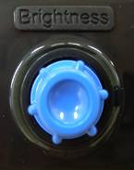

The Brightness on the screen of the SenseView D700 can be adjusted between level 1 to level 25 and the default level is 13.

You can use Control Brightness of the Screen with same way at the Front Controller and the External Controller.

- Brightness Up: Turn the ‘Brightness’ dial button to the right side
- Brightness Down: Turn the ‘Brightness’ dial button to the left side.
You can set specified Brightness according to each Color Mode. In other words, you can set level 10 of Brightness for Color Mode 1 and also can set level 20 of Brightness for Color Mode 2. Adjust the Brightness along with your preference.

  - Focus Lock

The SenseView D700 has the function of automatic focus and it will make user easy to read a book or material since it focus on the moving object automatically.

But when you will write letters, the auto-focusing function will be inconvenient. Since the SenseView D700 will focus on your hand or pen automatically as writing. In such a case, you can use Focus Lock function as below;

- In case of using the Front Controller;

- Focus Lock: Press the ‘Brightness’ dial button more than 3 seconds and release it, then the message of “F/LOCK” will show up on the screen and the ‘Focus Lock’ begin to work.
- Release Focus Lock(Auto Focus): Press the ‘Brightness’ dial button again more than 3 seconds on the status of ‘Focus Lock’ and release it, then the message of “F/AUTO” will show up on the screen and will go back to Auto Focus.

- In case of using the External Controller;

- Focus Lock: Press the ‘Focus Lock’ button one time and then “F/LOCK” message will show up and the ‘Focus Lock’ begins to work with light on the ‘Focus Lock On/Off indicator’.
- Release Focus Lock(Auto Focus): Press the ‘Focus Lock’ button again and then “F/AUTO” message will show up and go back to Auto Focus and the ‘Focus Lock On/Off indicator’ will be turned off.

4.7 Split Screen
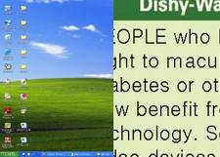

The monitor of the SenseView D700 will display an image of the PC and CCTV at the same time.
You can adjust window size of splitting screen.
The splint screen function will be operated only using the ‘Split’ dial button of the External Controller. And if you want to use this function, you have to set the resolution of the PC to 800x600. Otherwise, the split screen is not working properly.
Before using of the split screen, you have to change setting along with the port of in/output cable.

- In case of connecting in/output cable with the port of DVI-D
- It sets VGA image input at the first time, so press the ‘Picture Ratio Set’ button more than 5 seconds and then release it.
- “DVI Input’ will show up on the screen and the Input channel will change to DVI-D.
- You have to reboot your PC if you change this setting while the PC is turned on and set resolution of the PC as 800x600.

- In case of connecting in/output cable with VGA port

- If you do not change any setting value, you can use the Splint Screen function right away, since it sets VGA image input at the first time.
- If you change setting value and change to DVI image input, press the ‘Picture Ratio Set’ button more than 5 seconds and then release it.
- “VGA Input” will show up on the screen and the Input channel will change to VGA.
- You have to reboot your PC if you change this setting while the PC is turned on and set resolution of the PC as 800x600.


The image of the Magnification Module(CCTV) will display on the whole screen of the monitor and it is default of the Split Screen. There are 5 kinds of Split Screen, please refer to the following method;

- Vertical Split Screen 1: If you press the ‘Split Screen’ dial button one time, CCTV screen will be displayed on the left side of the screen and the PC screen will be displayed on the right side. Turn the ‘Split Screen’ dial button to the right side, the image size of the CCTV getting bigger and turn to the left side, getting smaller.


- Vertical Split Screen 2: When the ‘Vertical Split Screen 1’ show up on the screen, press the ‘Split Screen’ dial button again and then CCTV screen will be displayed on the right side of the screen and PC screen will be displayed on the left side.



- Horizontal Split Screen 1: When the ‘Vertical Split Screen 2’ show up on the screen, press the ‘Split Screen’ dial button again and then CCTV screen will be displayed on the up side of the screen and the PC screen placed on the down side. You can not change displayed area on the Horizontal Split Screen.

- Horizontal Split Screen 2: When the ‘Horizontal Screen 1’ show up on the screen, press the ‘Split Screen’ dial button again and then CCTV screen placed on the down side of the screen and PC screen placed on the up side. You can not change displayed area on the Horizontal Split screen.


- When the ‘Horizontal Split Screen 2’ show up on the screen, press the ‘Split Screen’ dial button again and then Split Screen function is released and PC screen will be displayed on the monitor.
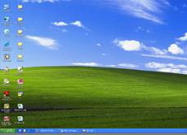

- If you want to use the monitor for CCTV after release of Split Screen function, press the ‘Split Screen’ dial button again.

If you press the ‘Split Screen’ dial button each time, circulating above 6 kinds of the Split.

4.8 Picture Ratio Set

You can set picture ratio of the monitor between 4x3 and 16x9.
To change the picture ratio, turn off the power, press and hold “Marker” dial button and turn SenseView D700 on. Then 4x3 or 16x9 will be displayed on the screen. The 16x9 ratio is default.
- In case of using the Front Controller
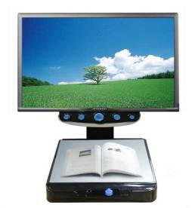

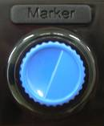
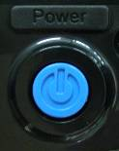

When the SenseView D700 is tunred off, press the ‘Marker’ dial button and hold on, then turn the SenseView D700 on. Release the ‘Marker’ dial button when the message of “4x3” or “16x9” shows up on the screen. If you turn the SenseView D700 on along with pressing ‘Marker’ dial button each time, picture ratio set will be changed.
- In case of using the External Controller
Press the ‘Picture Ratio Set’ button for switching between 4x3 and 16x9.

4.9 Light On/Off
If you install the SenseView D700 at the first time, the lighting is on. If you want to turn if off, move your hand from camera of the SenseView D700 to the pillar and then you can find lighting switch.

4.10 Setting Beep Sound and Voice

You can use this function using the External Controller only.
It provides 4 kinds of setting like as No Sound, Beep Sound Only, Voice Feedback Only and Beep and Voice Feedback.

- Mute (no sound): It is default setting and the voice or beep sound is not output when you press every single button.
- Beep Sound Only: When the ‘Mute’ is on, press the ‘Beep Sound and Voice’ button one time and then the beep sound will come out when you press or turn every single button.
- Voice Feedback Only: When the ‘Beep’ sound is on, press the ‘Beep Sound and Voice’ button again and
then voice feedback will come up when you press or turn every single button.
- Beep and Voice Feedback: When the ‘Voice Feedback’ is on, press the ‘Beep Sound and Voice’ button again and then beep and voice feedback will come up when you press or turn every single button.

If you press the ‘Beep Sound and Voice’ button each time, above 4 sounds will circulate.
Setting Beep Sound and Voice will be saved when the SenseView D700 is turned off. In other words, if you set one sound and turn the SenseView D700 off and then turn it on again, the SenseView D700 will work with last saving sound.

4.11 Setting Date and Times

You can use this function using the External Controller only.

Pressing the ‘Date and Time’ button on the External Controller will show you the date and time on the monitor.
If you want to change the date and time, press the ‘Date and Time’ button more than 3 seconds and then you can set new date and time using the ‘Focus Lock’ dial button and the ‘Marker’ dial button. Please refer to the below detailed method;

- When date and time are displayed on the screen, press the ‘Date and Time’ button more than 3 seconds and release it.
- The date and time will blink, press the ‘Focus Lock’ button one time and then ‘Year’ will blink.
- Turn the ‘Marker’ dial button to the right side or left side in order to find your desired year. If the desired year is displayed, press the ‘Focus Lock’ button once and then ‘Year’ will be set and move to ‘Month’.
- The ‘Month’ will blink and you can select desired month by turning the ‘Marker’ button and press the ‘Focus Lock’ button in order to set month. The ‘Month’ will be set and move to ‘Day’.
- The ‘Day’ will blink and you can select desired day by turning the ‘Marker’ dial button and press the ‘Focus Lock’ button in order to set day. The ‘Day’ will be set and move to setting of time.
- The ‘Hour’ will blink and you can select desired hour by turning the ‘Marker’ dial button and press the ‘Focus Lock’ button in order to set hour. The ‘Hour’ will be set and move to ‘Minute’.
- The ‘Minute’ will blink and you can select desired minute by turning the ‘Marker’ dial button and press the ‘Focus Lock’ button in order to set minute. The
‘Minute’ will be set and the set date and time shown on the screen.

During setting date and time, turn the ‘Marker’ dial button to the right side, the numbers are increased and turn to the left side, the numbers are decreased. And the year can be set from the year 2000 to 2099.
While the Line/Window markers on; if you set Date and Time, the Line/Window markers will be cancelled automatically.

5. SPECIFICATION
Magnification |  | 4x~73x(19" monitor)
Power |  | 12V/3A
Size |  | 340mm(w) x 467mm(d) x 361mm(h)  (except the Hinge)
Basic Mode |  | 1. Full Color  2. High Contrast Color  3. Black / White  4. White / Black  5. Yellow / Black  6. Blue / Yellow  7. Blue / White  8. White / Blue
Selection of Color Mode |  | - Full Color, Monochrome, 16 kinds of high contrast color (Black/White, Blue/White, Green/White, Red/White, Pink/White, Bluish Green/White, Yellow/White, Black/Blue, Black/Green, Black/Red, Black/Pink, Black/Bluish Green, Black/Yellow, Bluish/Red, Pink/Green, Yellow/Blue)  - Support negative mode for each color mode except Monochrome mode)
Weight |  | 11 Kg(including Display Module: 18Kg)
Output Resolution |  | 800 X 600
In/Output | Input | - Input port for connection of the PC(VGA)  - - Support DVI-D
In/Output | Output | - Output port for connection of the monitor(VGA)  - Output port for connection of the monitor(DVI-D)  - Speaker(0.5W)
※ NOTE: This user guide will be differed from actual operation due to improved function of products and it is subject to change and modified without prior notice.


NOTE: This equipment has been tested and found to comply with the limits for a Class B digital device, pursuant to part 15 of the FCC Rules. These limits are designed to pro-vide reasonable protection against harmful interference in a residential installation.
This equipment generates, uses and can radiate radio frequency energy and, if not in-stalled and used in accordance with the instructions, may cause harmful interference to radio communications. However, there is no guarantee that interference will not occur in a particular installation. If this equipment does cause harmful interference to radio or television reception, which can be determined by turning the equipment off and on, the user is encouraged to try to correct the interference by one or more of the following measures:
-Reorient or relocate the receiving antenna.
-Increase the separation between the equipment and receiver.
-Connect the equipment into an outlet on a circuit different from that to which the receiver is connected.
-Consult the dealer or an experienced radio/TV technician for help.

CAUTION: Changes or modifications not expressly approved by the manufacturer responsible for compliance could void the user’s authority to operate the equipment.

